**Scenario: User bypasses SSL warning**

**Step: Launch "koenigsegg_page" WebPage - PASS**

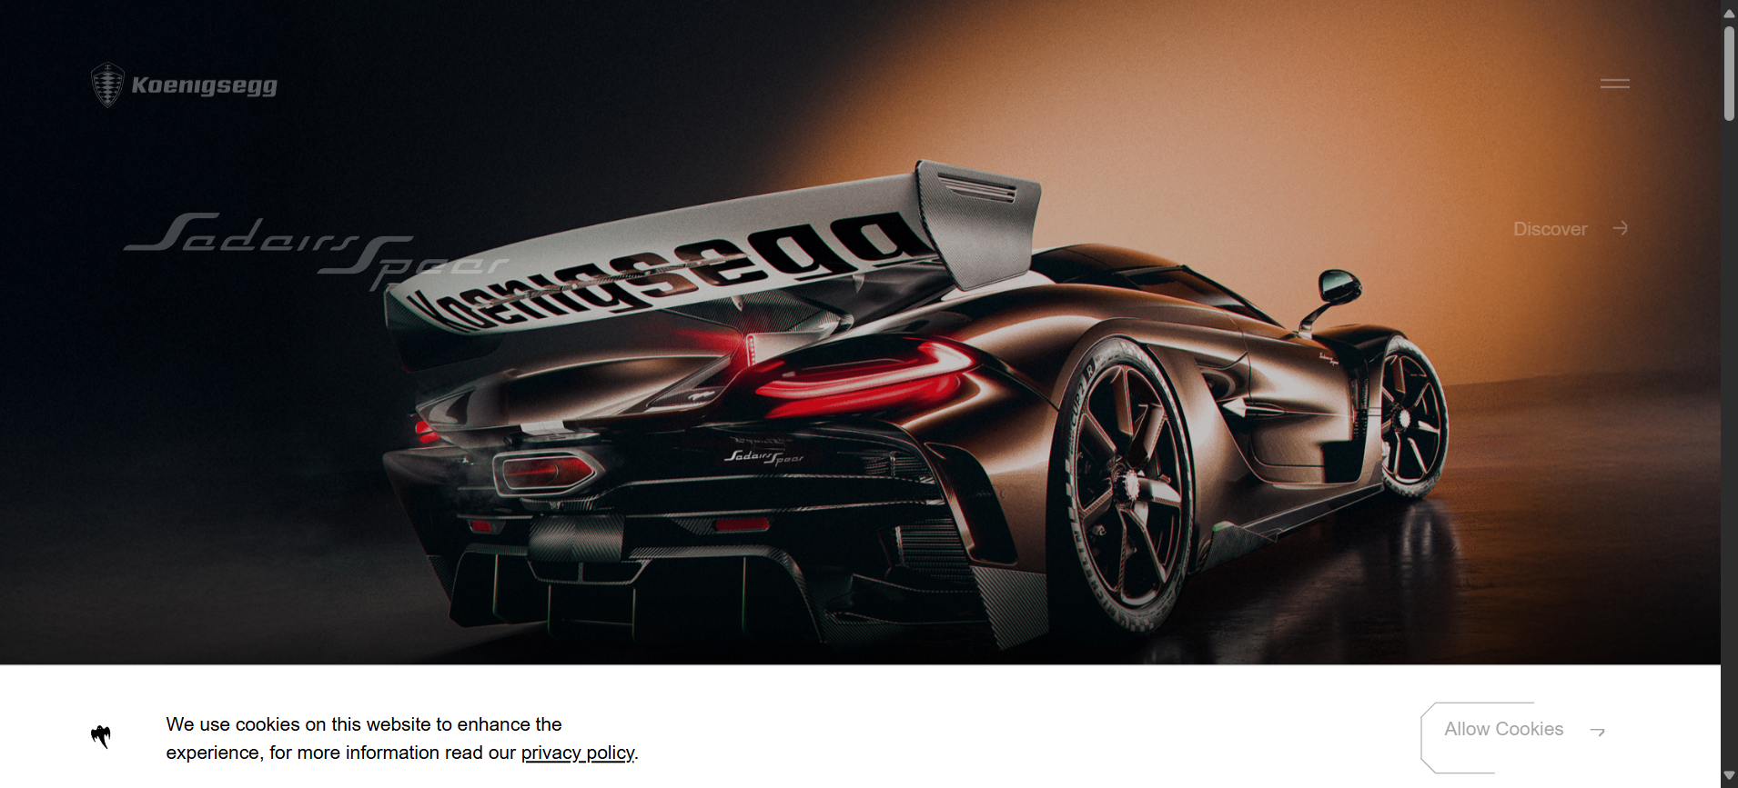

**Step: When the user clicks the Advanced option and clicks Proceed - PASS**

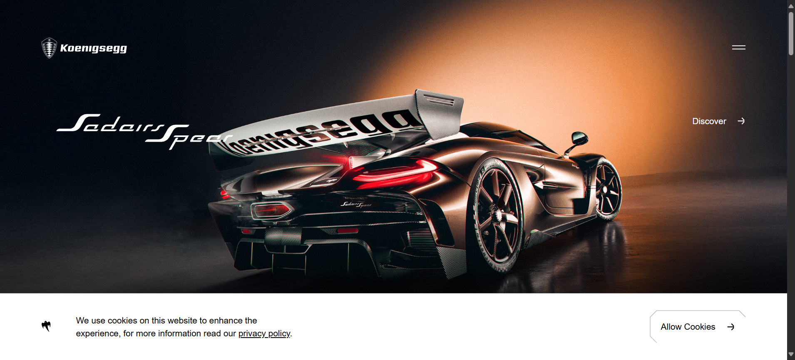

**Step: Then the user validate the page URL with"https://www.koenigsegg.com/home" - PASS**



**Execution Summary:  
Total Steps: 3  
Passed: 3  
Failed: 0**